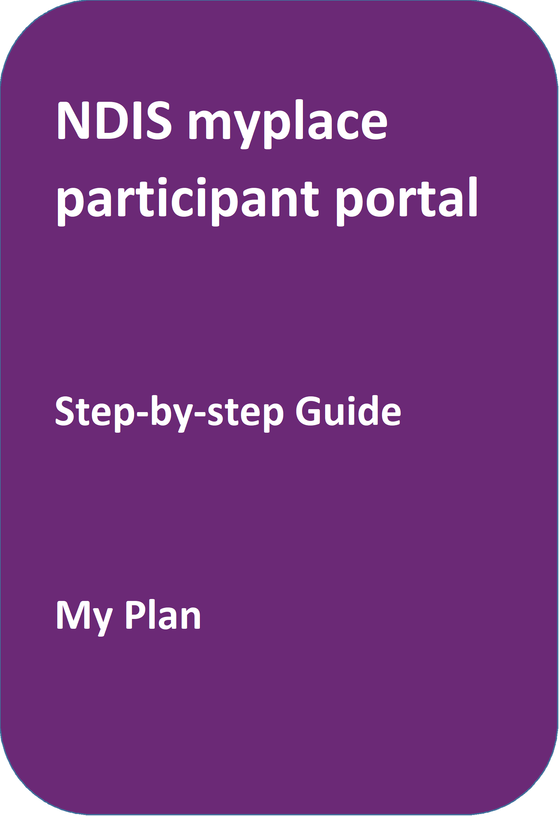

**portal**

May 2024

## **Table of Contents**

Table of Contents 2

Changes from the last version 3

My Plan 3

My support budget 10

My Referrals 15

## Changes from the last version

The following updates have been made to the last published version of the myplace portal step-by-step guide:

* General updates.

## My Plan

The My Plan tile displays once you have an approved NDIS plan. You can view your current and previous plans, your support budget, and any referrals.

**Note:** If you have a new plan in our new computer system, you can only view your previous plan information in myplace portal. You need to sign in to the my NDIS portal to see your current plan information or your previous plan created in the NDIS business system.

1. Select the **My Plan** tile on the homepage.

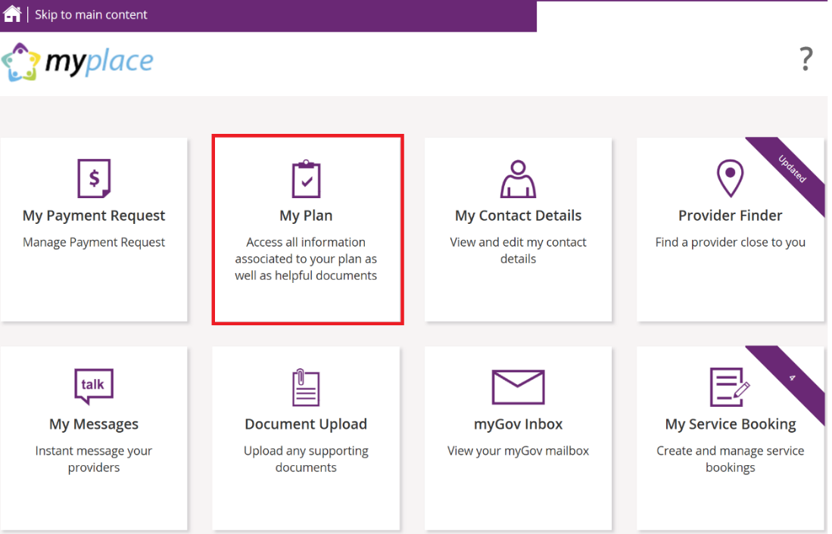

Once the **My Plan** tile opens, you will see the following tiles:

* View My Plan
* My Helpful Documents
* My Support Budget
* My Referrals
* My Funding Report

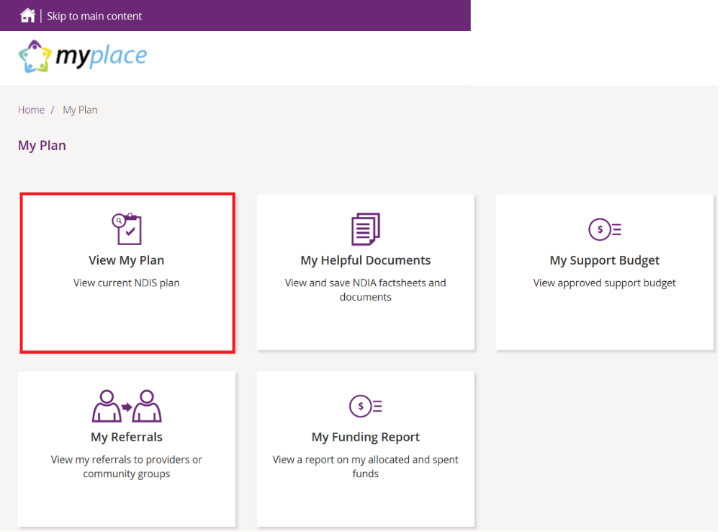

**View my plan**

All information about your plan is available in **View My Plan**. You can keep track of your plan review date, days remaining, My NDIS contact, goals, profile, funded supports information and access additional information in the **Find out more** section. You can also view previous plan information. This is a view only section of the portal.

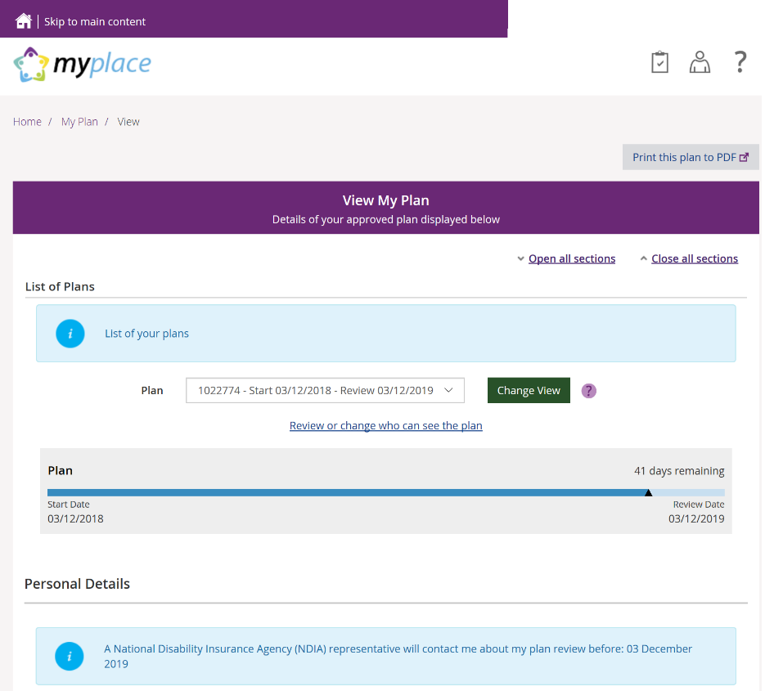

1. Your current plan defaults. If you want to select a previous plan, use the **Dropdown Arrow** in the **List of Plans** section.

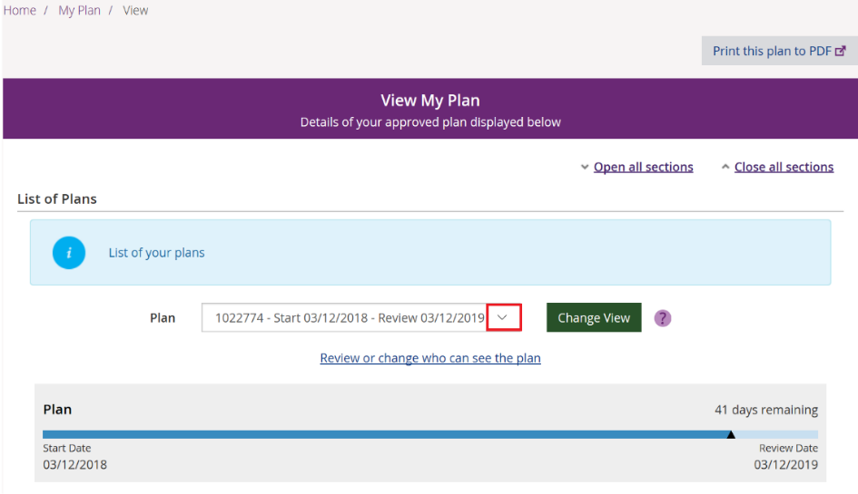

**Note**: To view a past plan, use the **Change View** button.

1. Click the **Open all Sections** link to view all the information under each of the headings.
2. To print a copy of your plan, click on the **Print this plan to PDF** button on the top right hand corner of the screen.

**Note:** In some instances you may not be able to preview or print a copy of the plan and you will see this message:

#### ‘Plan document could not be retrieved. Please [contact us](https://www.ndis.gov.au/contact) to request a copy of this plan’



If you see this message and you cannot view a copy of the plan please [contact the NDIS](https://www.ndis.gov.au/contact) for help.

**View my plan: section of the plan**

The **Personal Details** section displays your NDIS Number, My NDIS Contact, the plan start and review due date and the length of the plan in months.

Contact the NDIS if you have any changes to your circumstances, which could change the supports you need to be included in your plan.

The personal details screen displays your NDIS number, NDIS plan start date, NDIS plan review date and the plan length in months.
 At the top of the screen is an information tab displaying information that an NDIA representative will contact the participant about their plan review before a due date.

The **Profile** section outlines key information about you, such as your date of birth, current contact details, information about yourself (About me) and who supports you.

**The Participant Goals outlines the goals you want to achieve and how you will achieve them and how you will be supported.**

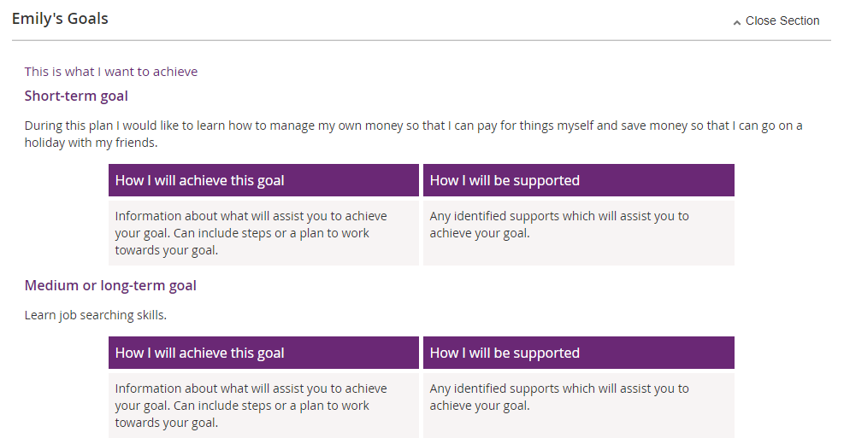

The **Funded Supports** section outlines the supports funded by the NDIS to help you achieve your goals. There is information on what the funding can be used for, how it is managed (e.g. self-managed) as well as how this funding amount is divided across the support categories (or budgets) in your plan.

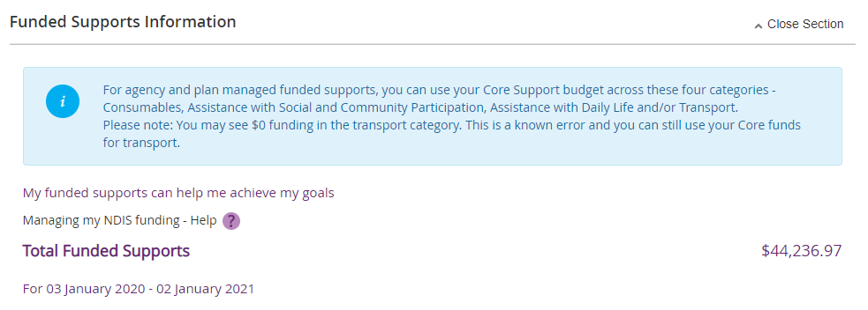

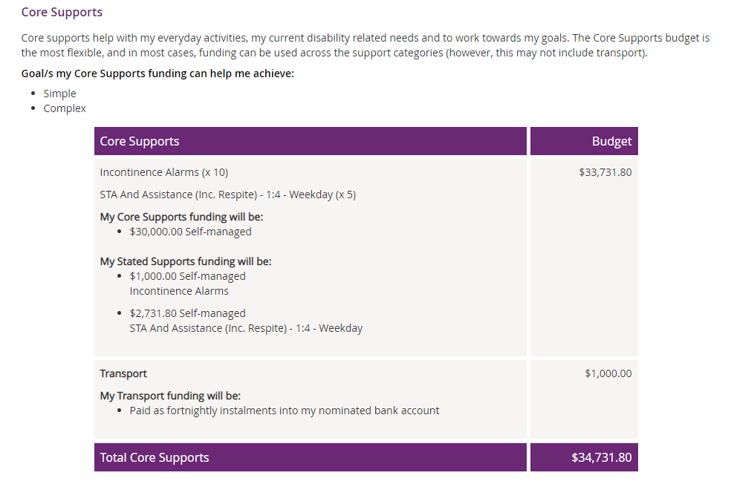

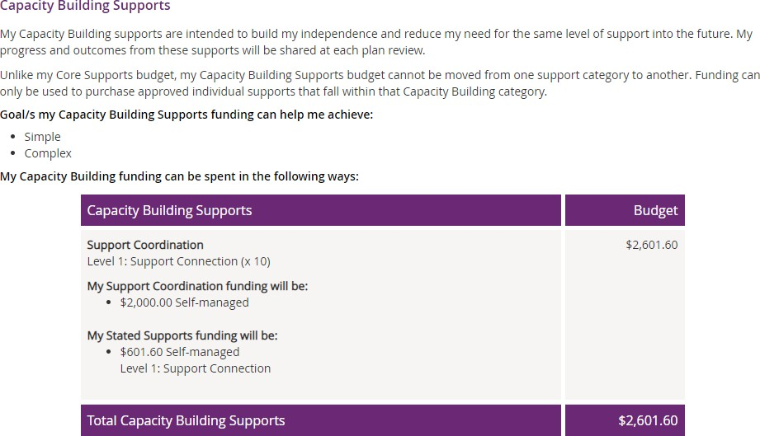

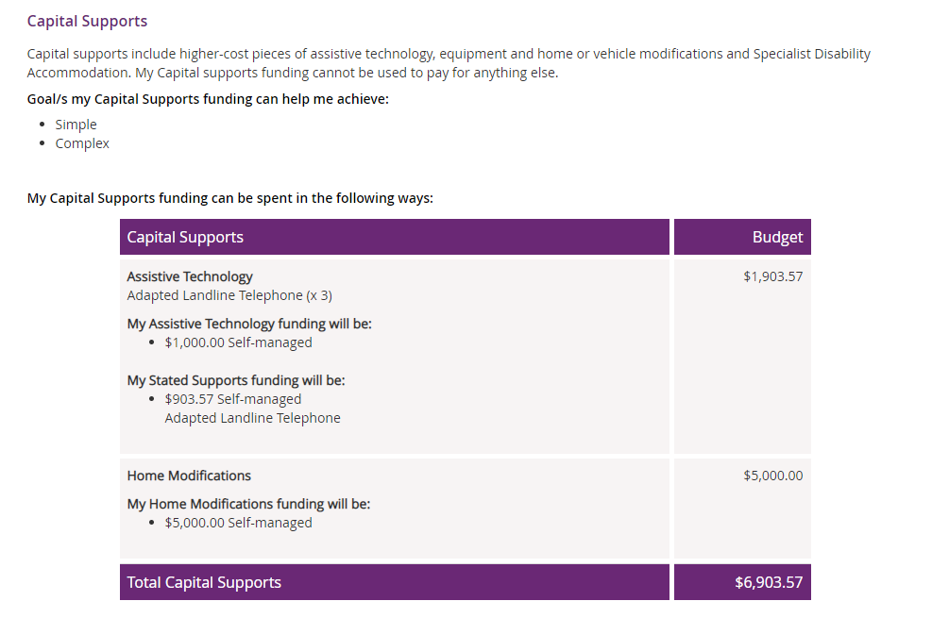

**Note:** Any items that require a quote will display as **Quote required** on your plan until a quote is approved by the NDIA. Once approved, the final quoted amount will display.

The **Find out more** section has information about who to contact if you need help with your plan, the [Booklet 3 – Using your NDIS Plan](https://www.ndis.gov.au/medias/documents/pathway-booklet3-pdf/NDIS015-Participant-Pathwa-y-Book3-20pp-A4-Accessible-.pdf) and other ways to contact the NDIS.

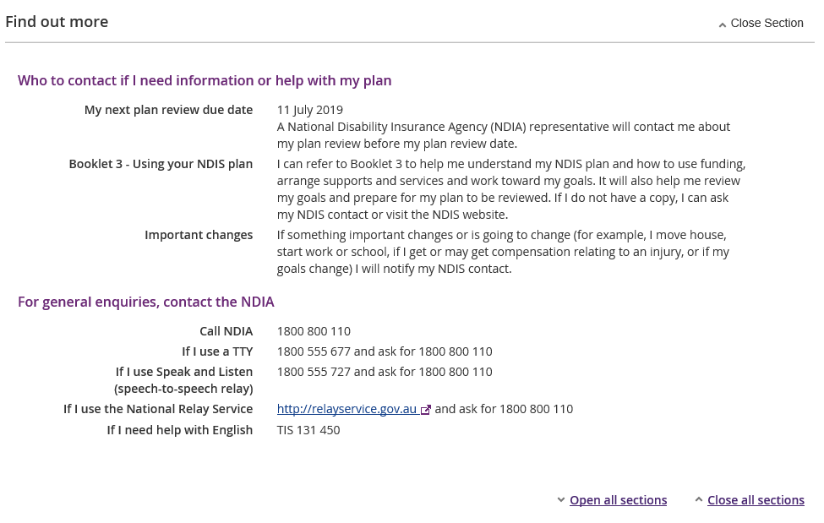

1. Click the **My Plan** link at the top of the page to navigate back.

my plan option which can be selected to navigate back to the homepage

## My support budget

**My Support Budget** is a summary of your current plan support budget. You can compare your approved funds, allocated, spent and remaining budget. The budget is also broken down by how the funding is managed (i.e. Agency, Plan or Self).

**Note**: Move your cursor over the question icons on the screen for further information about terms or features.

1. Click on the **My Support Budget** tile on the **My Plan** page.  
    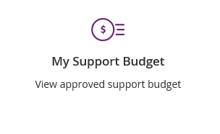

The **My Support Budget** screen displays.

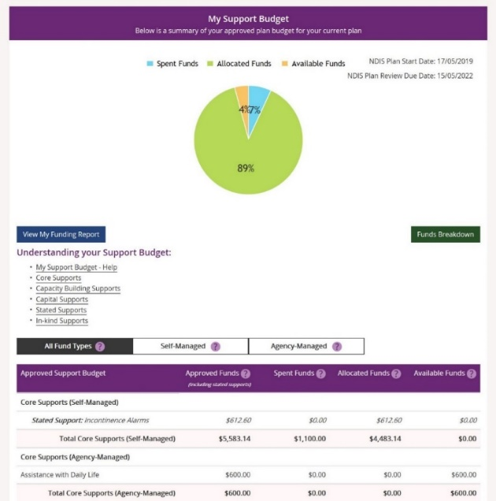

Your plan start and scheduled review dates are shown at the top of the screen. A pie chart displays in percentages your Spent Funds, Allocated Funds and Available Funds. Moving your mouse cursor over the pie chart shows the dollar values.

The **Understanding your Support Budget** section has links to information explaining:

* My support budget –Help
* Core supports
* Capacity building supports
* Capital supports
* Stated supports
* In-kind supports

1. 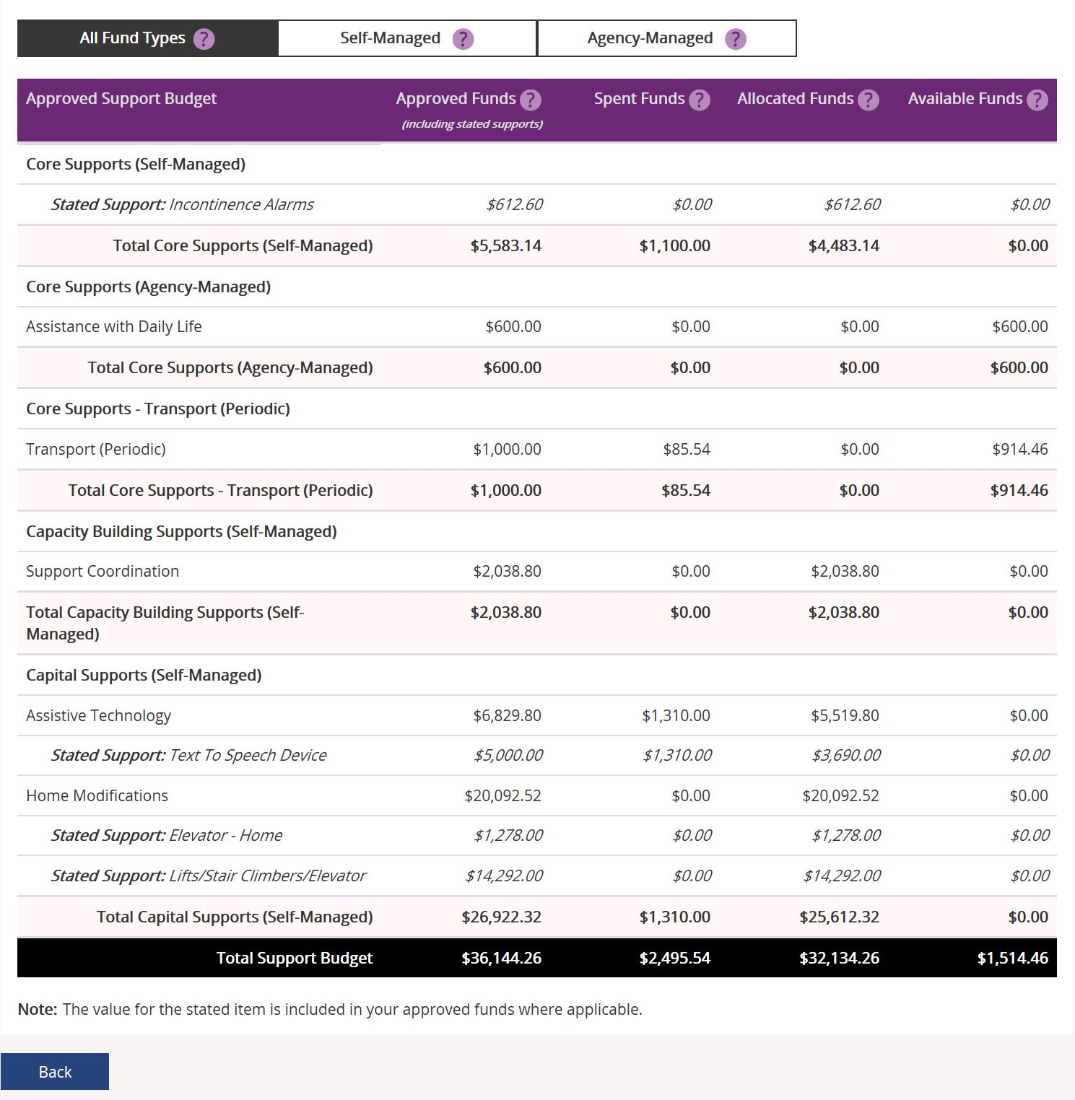Scroll down the page to view the funds table. It shows Approved Funds, Spent Funds, Allocated Funds and Available Funds for each support type and support category.
2. You can view the budget by your funds management breakdown by selecting from the tabs available (for example, Self-Managed). The **All Funds Type** is the total values of the support budget.

**View my funding report**

The funding report provides a summary of allocated and spent funding in your plan organised by self-managed supports, agency managed supports and plan managed supports (if applicable). The funding report includes information on service booking dates and last payment request information.

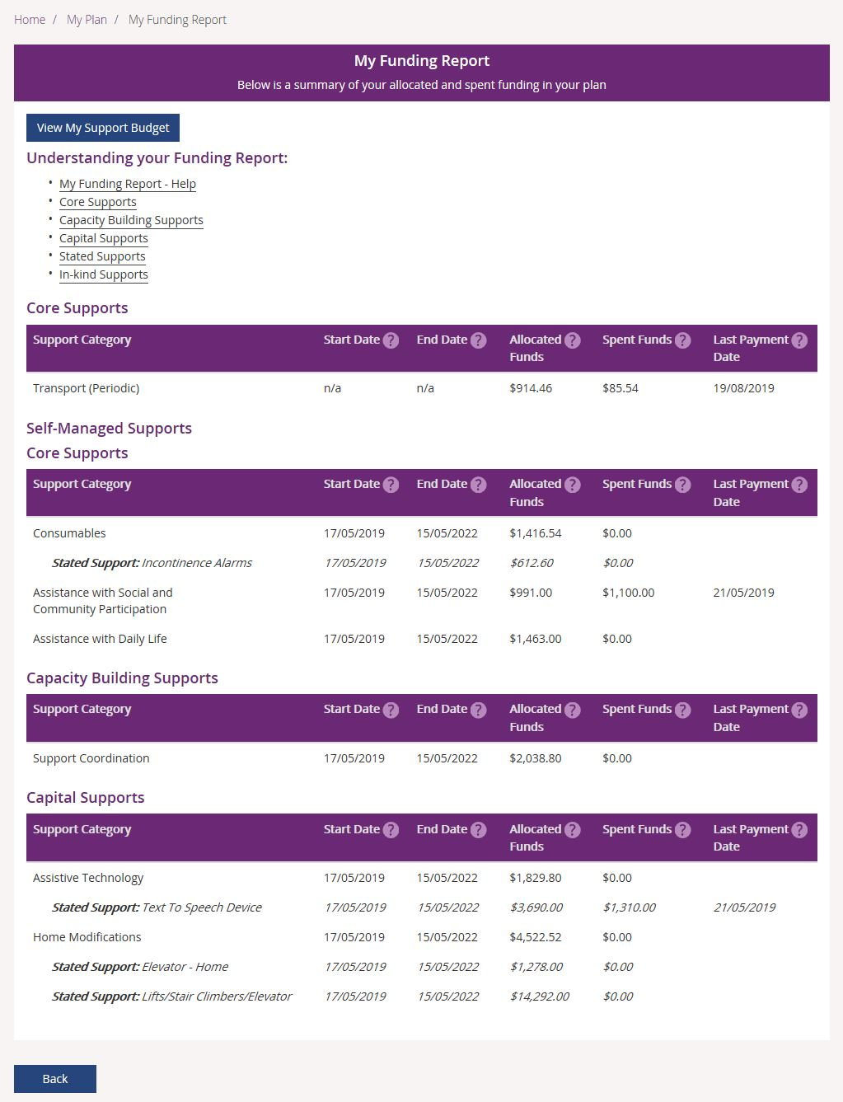

You can also access **My Funding Report** by selecting the **My Funding Report** from the **My Plan** home screen.

You can select the **View My Support Budget** button at the top of the screen to return to the **My Support Budget** screen or **Back** to return to the My Plan page.

Funds breakdown

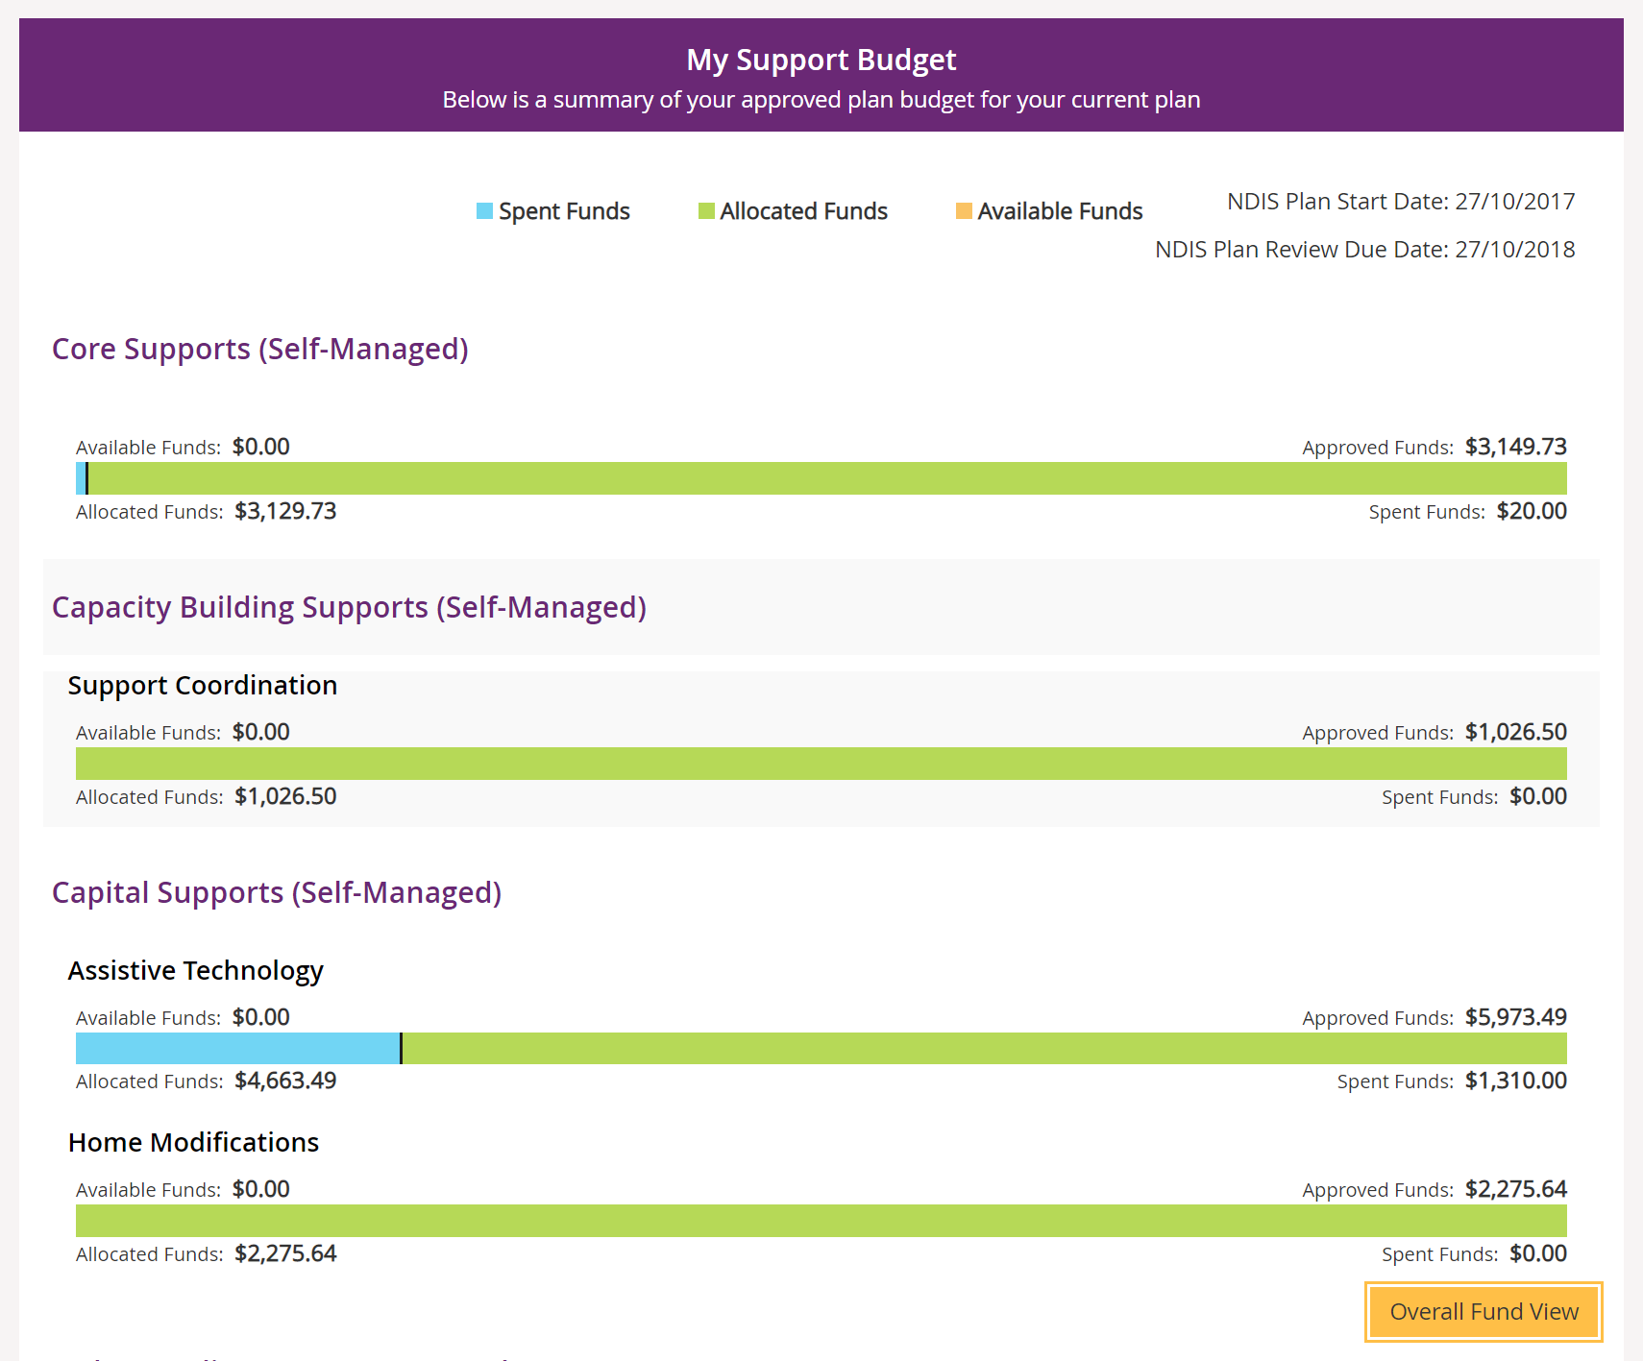

1. Click the **Funds Breakdown** button to the right of the pie chart to view the funds

information as a set of bar graphs.

The screen changes to display a detailed view of:

* What funds have been approved in your plan for each support category and support type
* What has been spent, what has been committed and what remains for each support type and support category
* Whether your support for each support category is agency managed, plan managed or self-managed.

**Note**: The figures shown do not include Payment Requests that have been submitted but not processed.

## My Referrals

Your planner can add referrals to your plan and these can be viewed through **My Referrals**.

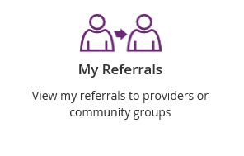

1. Click the **My Referrals** tile on the **My Plan** page and your current referrals will display.

You can refine your list of referrals by using the **search by** field to select either registered providers or community groups.

2. Select **Back** to return to the portal home page.